Student’s name | …………………………………………………….…… | Grade | 6
Subject | Computer | Week No. | 12
Lesson Title | Cyber Security | Unit
Worksheet No. ( 12 ) (Answer)

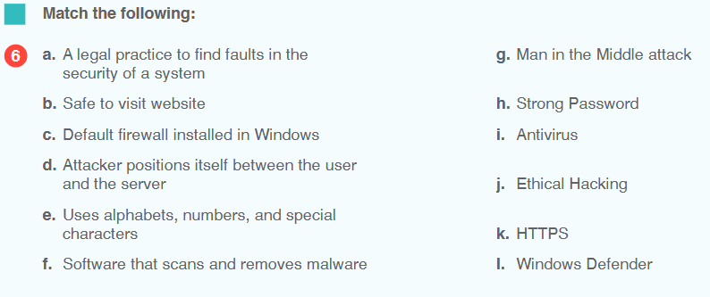
Question A:

Good Luck

